**Leaderboard Project Proposal**

**Conor Driscoll**

**SE266.**

**11/18/2024**

# Project Summary

Project Description

The core of the project is a website that could be used to create and browse leaderboards. Users would make an account to establish ownership of leaderboards, and allow a way to “follow” leaderboards to have them be easier to access for the users. The creation of the leaderboard would be pretty simple, allowing the user to designate a field that would be sorted as well as if it was going to be ascending or descending (Highest or lowest number winning). The addition of a “invite only” leader board is on the list of optional features I may add if I have extra time.

## Functionality

* User Creation/Authentication
  + Allows users to create an account to store relevant information
  + Authorization features
* Database management
  + User table
  + Leaderboard table
  + Submission table
* Data Display
  + Shows all created leaderboards being selectable
    - Once selected shows the top 20 submissions (possibly with tabs or scrolling capability to show the rest of the submissions)
* Leaderboard Creation
  + Designate a key field to base the leaderboard positions on, and if its ascending or descending
  + Designate if it is public or invite only (or maybe a friend list only)
  + Designate if verification for a submission is required

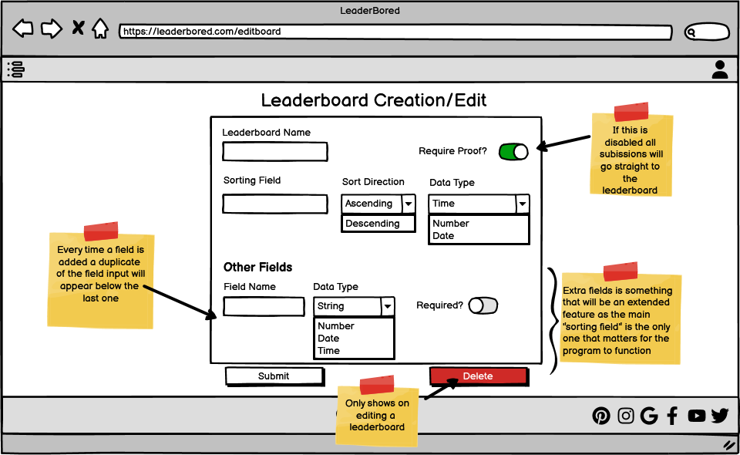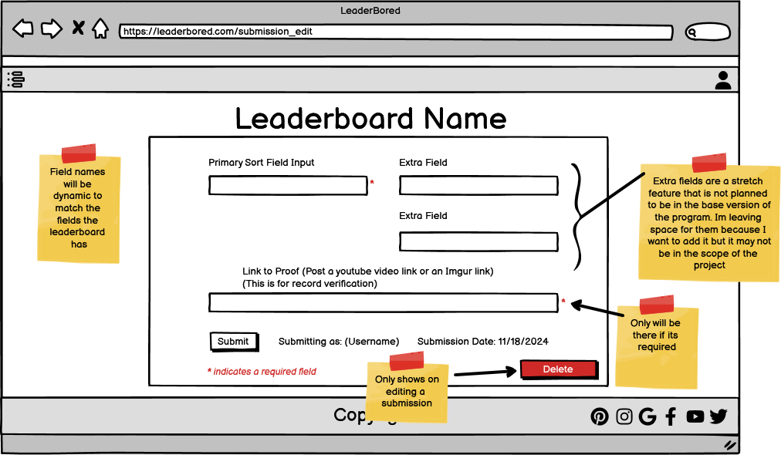

# Technical Specifications

### Folder Structure

* Site
  + Includes
    - header.php
    - footer.php
    - functions.php
  + Models
    - db.php
    - dbconfig.ini
    - model_users.php
    - model_leaderboards.php
    - model_submissions.php
  + index.php
  + login.php
  + user_view.php
  + leaderboard_edit.php
  + leaderboard_view.php
  + submission_edit.php

### model_users.php

* contains database functions for users
  + getUsers()
  + getUser(id)
  + addUser(username,password)
  + deleteUser(id)
  + login(username,password)
  + logoff()

### model_leaderboards.php

* contains database functions for leaderboards
  + getLeaderboards()
  + getLeaderboard(id)
  + addLeaderboard(ownerID, name, sortFieldName, sortFieldType, sortDirection, isValidationReq)
  + deleteLeaderboard(id)
  + updateLeaderboard(id, name, sortFieldName, sortFieldType, sortDirection, isValidationReq, description)
  + searchLeaderboards(name)

### model_submissions.php

* contains database functions for submissions
  + getSubmissions()
  + getSubmission(id)
  + addSubmission(userID, leaderboardID, score, scoreType, verified)
  + deleteSubmission(id)
  + updateSubmission(score,verified)
  + searchSubmissions(id,userID, leaderboardID)

### user_view.php

* Displays the info for the currently logged in user
* Locked to currently logged in users
* Logged in user can use this page to delete their account
* Allows you to log out of your account
* Allows to go to leaderboards that you submitted to, as well as edit those submissions
* Allows you to view the leaderboards you have created

### login.php

* Allows a user to log in or sign up to the site
* Available to all users

### leaderboard_view.php

* Displays the info on a leaderboard
* Available to all users
* Adds a submission button to the leaderboard if user is logged in
* If the currently logged in user is the owner the page will change to allow for editing and verification/editing/deletion of submissions

### leaderboard_edit.php

* Creates a new leaderboard or edits one that already exists.
* Locked to logged in users
* If editing a leaderboard a deletion button will appear

### submission_edit.php

* Creates a submission for a leaderboard or edit one that already exists
* Locked to logged in users
* If editing a submission a delete button shows up, and If you change the score it will show a warning that it will need to be re-verified
* Displays your username and the current date that will automatically be added to the submission
* Will have verification on required fields before you can submit

# Database Specifications

## SQL

### SUBMISSIONS

CREATE TABLE IF NOT EXISTS lbSubmissions (

id INT UNSIGNED AUTO_INCREMENT NOT NULL PRIMARY KEY,

userID INT NOT NULL,

boardID INT NOT NULL,

score VARCHAR(50) DEFUALT NULL,

scoreType VARCHAR(50) DEFUALT NULL,

isVerified bit

)

### LEADERBOARDS

CREATE TABLE IF NOT EXISTS lbLeaderboards (

id INT UNSIGNED AUTO_INCREMENT NOT NULL PRIMARY KEY,

lbName VARCHAR(50) DEFUALT NULL,

ownerID INT NOT NULL,

sortFieldName VARCHAR(50) DEFUALT NULL,

sortFieldType VARCHAR(50) DEFUALT NULL,

sortFieldDirection VARCHAR(10) DEFUALT NULL,

isValidationReq BIT,

description TEXT DEFUALT NULL

)

### USERS

CREATE TABLE IF NOT EXISTS lbUsers (

id INT UNSIGNED AUTO_INCREMENT NOT NULL PRIMARY KEY,

username VARCHAR(50) DEFAULT NULL,

password VARCHAR(50) DEFAULT NULL

) ENGINE=InnoDB DEFAULT CHARSET=utf8 COLLATE=utf8_unicode_ci AUTO_INCREMENT=1;

INSERT INTO lbUsers SET username = "doug", password = *sha1(CONCAT("Salty-Spitoon", "password"));*